Contents
Commonly-used terms 1
Launching Visual Studio 2
Navigating Visual Studio 5
Solution files (.SLNs) 5
Shared data sources (.RDS) 7
Shared datasets (.RSD) 8
Reports (.RDLs) 9
Moving files in Visual Studio 10
Deploying files from Visual Studio 12

Additional Guidance
Knowledge Article: not yet written
HOW TO - Manage Reports - Access Permissions within HR Reporting.docx
HOW TO - Manage Reports - Change Processes in OSM.docx
HOW TO - Manage Reports - HR Reporting Environments.docx
HOW TO - Manage Reports - Parameters.docx
HOW TO - Manage Reports - Release and Deployment.docx
HOW TO - Manage Reports - Shared Data Sources.docx
HOW TO - Manage Reports - Shared Datasets.docx
HOW TO - Manage Reports - Troubleshoot Common Errors.docx

This document provides information that you will need when working in Visual Studio, including how to launch the application, how to navigate around it, and an explanation of commonly-used terms. This is not a process document so much as a “contextual information” document which you may find useful when you initially begin creating and editing reports in Visual Studio.

Commonly-used terms
There are a number of commonly-used terms that appear throughout this document. A brief explanation of each is given here.

Term | Notes | Example
Dataset | A dataset is the SQL code which queries the PeopleXD database and returns results. It can be embedded (unique to a single .RDL file) or shared (available to re-use across multiple .RDL files). | “DataSet1” within any .RDL file contains the report SQL code.
Dataset (Embedded) | An embedded dataset is a SQL query which is unique to a single .RDL file. | All report queries are “embedded” datasets.
Dataset (Shared) | Shared datasets are SQL queries which are available to re-use across multiple .RDL files. We use shared datasets to return Lists of Values (LOVs) which power parameter drop-down lists. | LOV_Optional_DepartmentCode
Data source | A data source is a connection to a PeopleXD database (UOXC, UOXP, etc.). | Oracle_DS_UserCredentials
Deployment | The act of publishing a report (.RDL file) or a shared dataset to one of the HR Reporting environments.
Design pane | The area of Visual Studio where you render the .RDL file.
Project | A project is a “sub-container” within a solution. The project is where your data sources, datasets, and reports are saved.  NB: A solution can contain multiple projects, but for HR Reporting, we have a strict 1-to-1 relationship between solutions and projects, such that each solution only contains a single project. | HR Reporting QA.sln contains project “HR Reporting QA”, which holds the data sources, shared datasets, and reports for the HR Reporting QA environment.
.RDL file | An .RDL file is a report; the terms are interchangeable. | PERDEP01 Full Data Set.RDL
Report | A report within Visual Studio is an individual .RDL file. | PERDEP01 Full Data Set
Report suite | A report suite is a group of .RDL files which all belong to the same “report”. | Every PERDEP01… .RDL which comprises PERDEP01 Staff in Post.
Service Account | The Service Account is a data source that has complete access to the PeopleXD databases, and which is allow unlimited connections to those databases. It is used to retrieve the LOVs for the shared datasets. | Oracle_DS_ServiceAccount
Solution | A solution (.sln) is simply a container Visual Studio uses to organize one or more related projects. When you open a solution, Visual Studio automatically loads all the projects that the solution contains. | HR Reporting QA.sln

Launching Visual Studio
Before you can create or edit reports, you will need to launch the Visual Studio application and select the solution file (.sln) that you want to work in.

Visual Studio is a remote desktop application. You can find it in your Start menu under “CONNECT Remote Services (RADC)”:

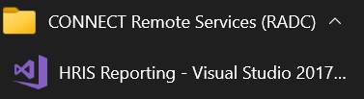

Double-click the entry in your Start menu to launch Visual Studio, and enter your CONNECT login details when prompted – these are necessary in order to access the CONNECT Remote Desktop:

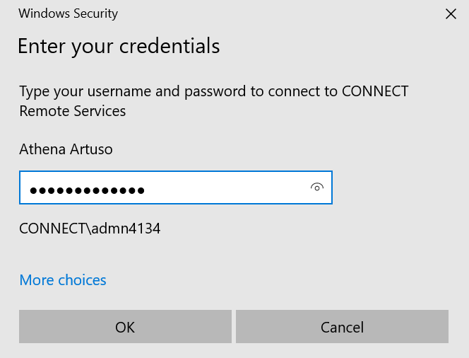

A little RemoteApp pop-up window will run while the application launches – this may be present for as long as a few minutes, so be patient:

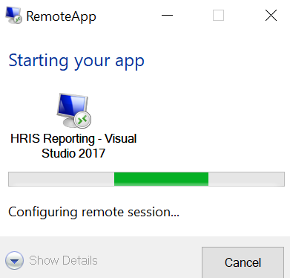

After a short wait, the Visual Studio splash screen will appear, followed by a sign-in window. Click the “Not now, maybe later” link at the bottom of the sign-in window:

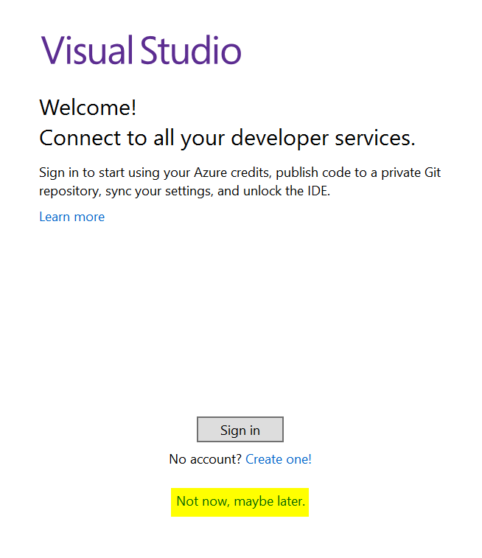

You’ll then be asked for your display preferences. Select Development Settings: General and click Start Visual Studio to complete the app launch.

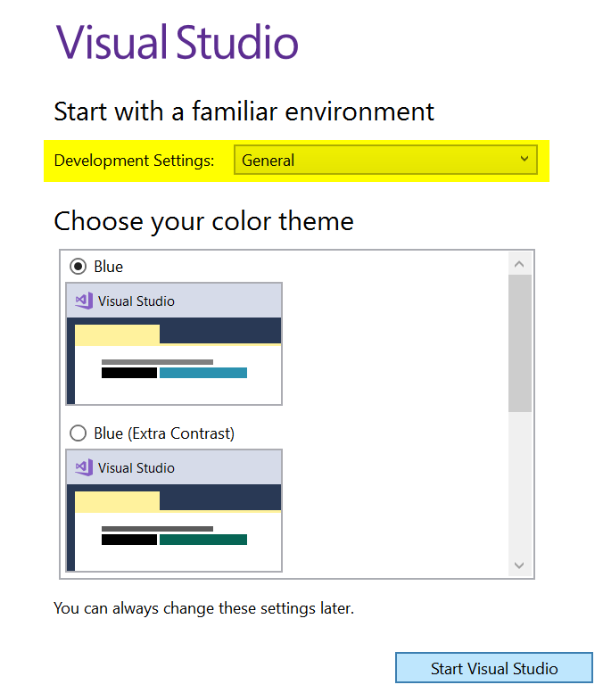

After another short wait (occasionally as long as a minute or two), Visual Studio will open and you will see the Home screen:

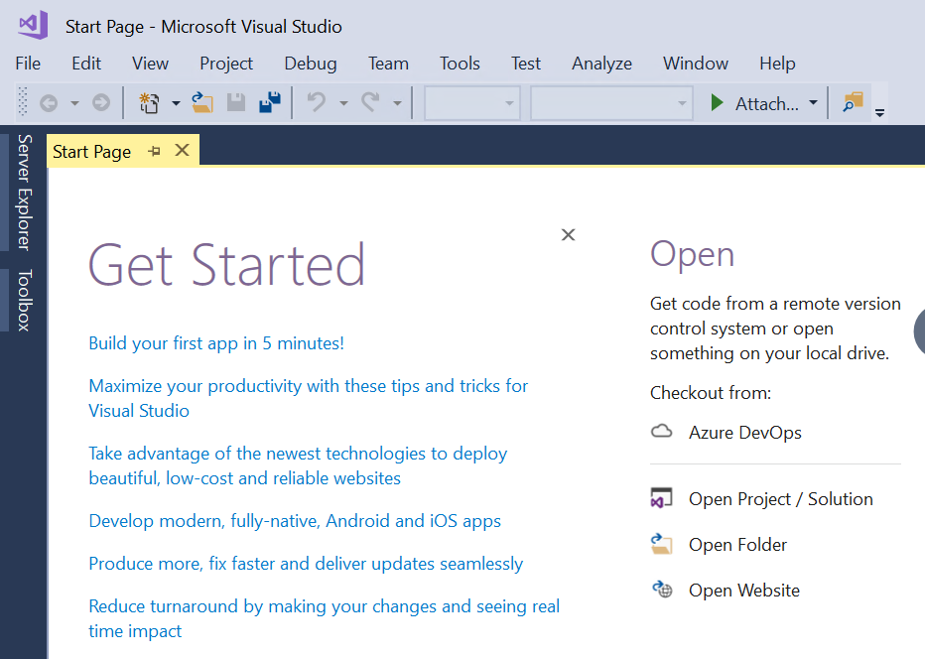

You are now ready to begin working in Visual Studio!

Navigating Visual Studio
Once you’ve successfully launched Visual Studio, you will need to navigate to the solution file you want to work in before you can create or amend reports, data sets, or data sources. See below for guidance on how to find your way around Visual Studio.

Solution files (.SLNs)
Files in Visual Studio are grouped into larger files called “solutions” (file extension .sln). A solution is effectively a “bucket” in which related files can be stored – there’s a lot more to this concept, but the important thing to remember is that each solution has its own data sources, datasets, and report files.

There are four HR Reporting solutions for you to choose from in Visual Studio.

Solution | Data source | Notes
HR Reporting DEV | Non-production (usually UOXC) | This is a sandpit environment for developing new reports.
HR Reporting TEST | Non-production (UOXZ, UOXC or UOXU) | This is a test environment, where you can test a new or existing report against a specific non-production data source
HR Reporting QA | Production (UOXP) | This is the UAT environment, where reports are deployed for testing by end-users. It is also where old versions of reports are archived.
HR Reporting LIVE | Production (UOXP) | This is the live environment, where final, approved drafts of reports are stored and published to the live server.

Which solution you open will depend on what you need to do, whether that’s developing a new report, performing unit testing of a new or amended report, readying a report for UAT by end-users, or publishing a final draft to the LIVE server.

To open a solution, go to File > Open > Project / Solution:

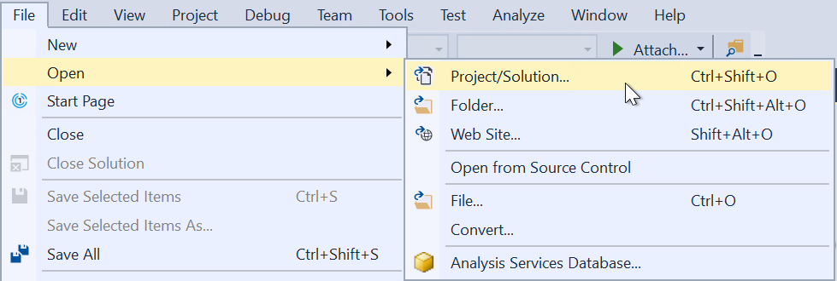

A warning message will appear; just click OK to dismiss it (there is no way to prevent this pop-up, but it has no impact on your ability to use Visual Studio):

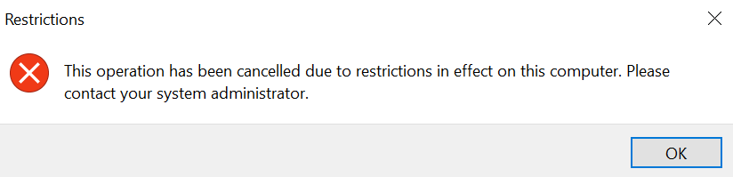

The Open Project file browser will open. You need to navigate to I:\OUIT\CoreHR Reports. This is a secure network drive owned by Microsoft Platform Services which is used for storing all HR Reporting files:

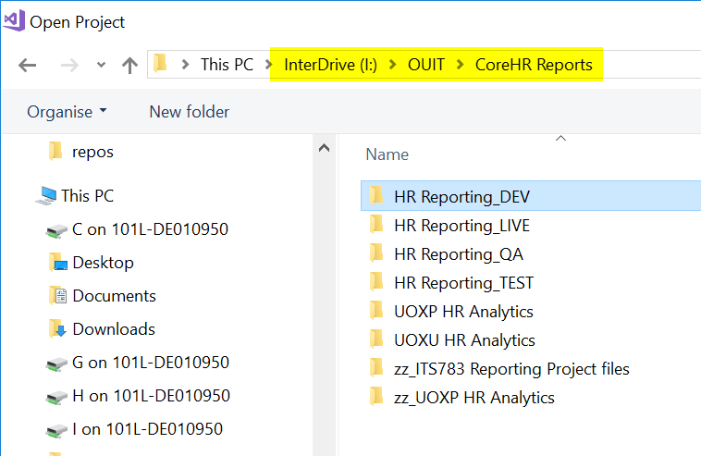

Choose the solution you wish to work in, and double-click the corresponding folder icon. Within the folder, select the solution file and double-click to open:

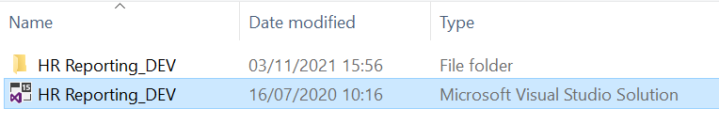

Another warning message will pop up; simply click OK to dismiss it:

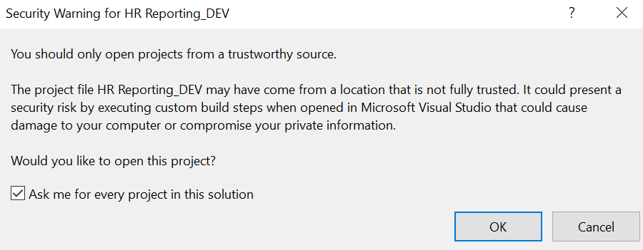

As with the previous pop-up, there is no way to prevent this message from appearing every time you use Visual Studio, but it won’t impact your ability to use the application.

After a moment, the solution file will load. You can always check which solution you have open by looking at the title bar or within the Solution Explorer pane:

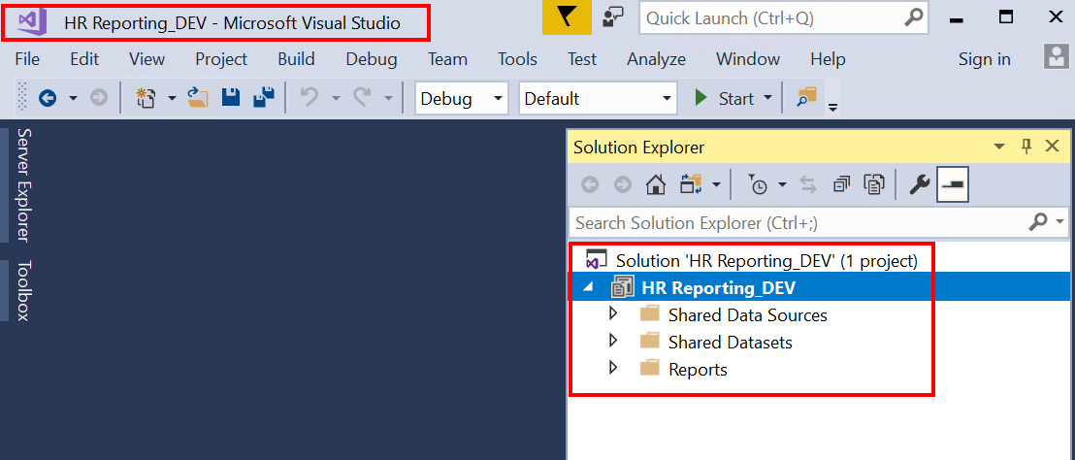

Once you’ve opened a solution, you can open any of the files contained within it. These include:

- Shared data sources (.RDS files)
- Shared datasets (.RSD files)
- Reports (.RDL files)

To open any of these files, go to the Solution Explorer pane on the right side of the screen and expand the folder which contains the file(s) in which you are interested. Double-click the file to open it.

 | NB: It is not possible to have more than one solution file open at a time. If you want to do some work in HR Reporting DEV and HR Reporting QA, for example, you will need to exit one solution before you can open the other.

Shared data sources (.RDS)
To open a shared data source (.RDS file), go to the Solution Explorer pane and expand the Shared Data Sources folder. You will be presented with a list of all the shared data sources currently available to open within the solution.

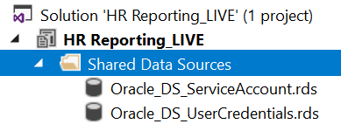

To open one, you can either double-click it, or right-click and select Open from the menu:

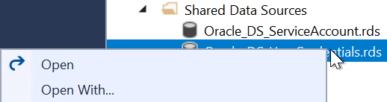
The Shared Data Source Properties window will open and the General screen will be displayed. The “Connection String” field will show you which PeopleXD database the current Visual Studio solution is connected to:

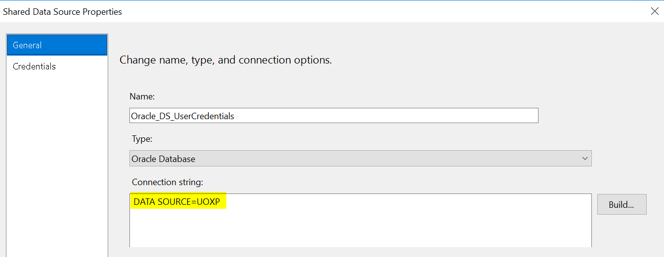

 | For more information on working with shared data sources, go to:  HOW TO - Manage Reports - Shared Data Sources.docx

Shared datasets (.RSD)
To open a shared dataset (.RSD file), go to the Solution Explorer pane and expand the Shared Datasets folder. You will be presented with a list of all the shared dataset files currently available to open within the solution.

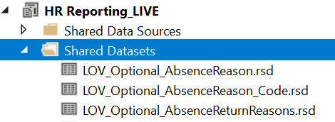

To open one, you can either double-click it, or right-click and select Open from the menu:

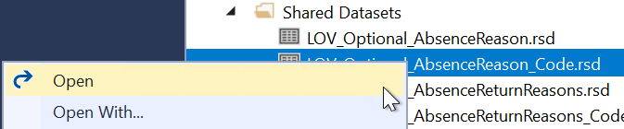

The Shared Dataset Properties window will open and the Query screen will be displayed. The Query screen holds the SQL code for the shared dataset – this code defines what information the shared dataset will retrieve from PeopleXD.

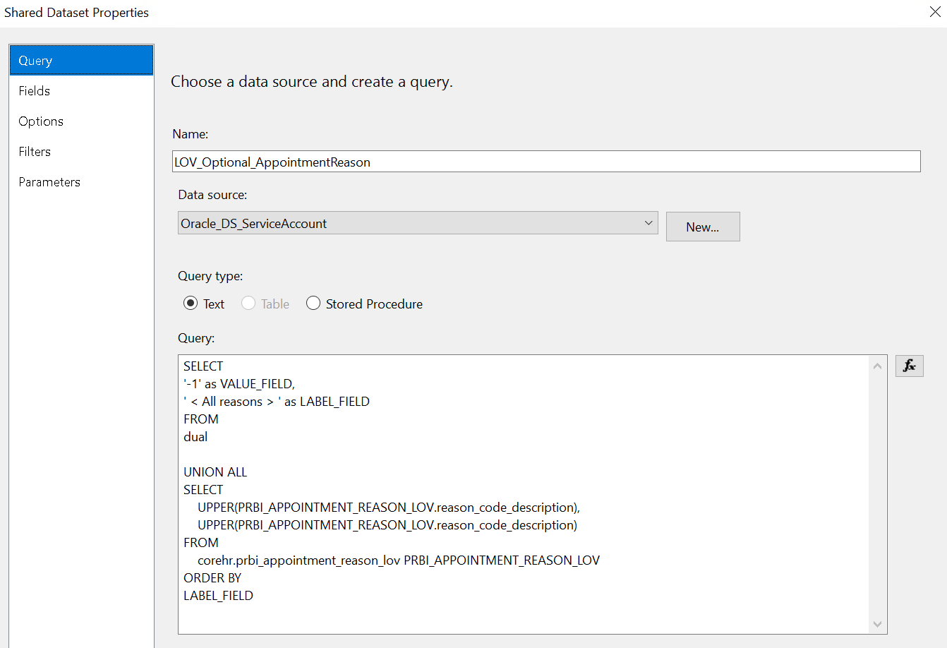

 | For more information on working with shared datasets, go to:  HOW TO – Manage Reports – Shared Datasets

Reports (.RDLs)

To open a report (.RDL file), go to the Solution Explorer pane and expand the Reports folder. You will be presented with a list of the report files currently available to open within the solution.

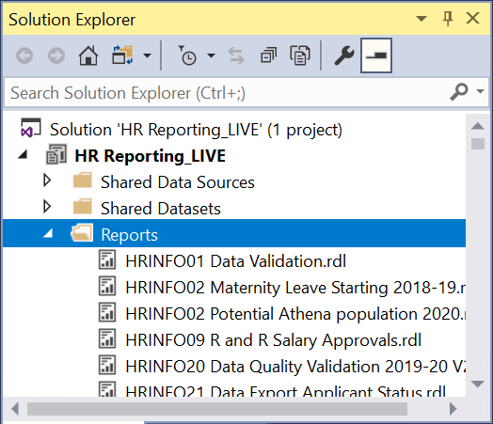

Scroll to the report you wish to open and either double-click it, or right-click and select Open from the menu:

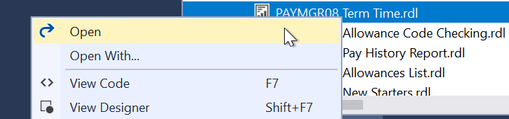

The .RDL file will load and the report’s Design pane will be displayed – this is where you can format the data from your SQL query into a user-friendly report.

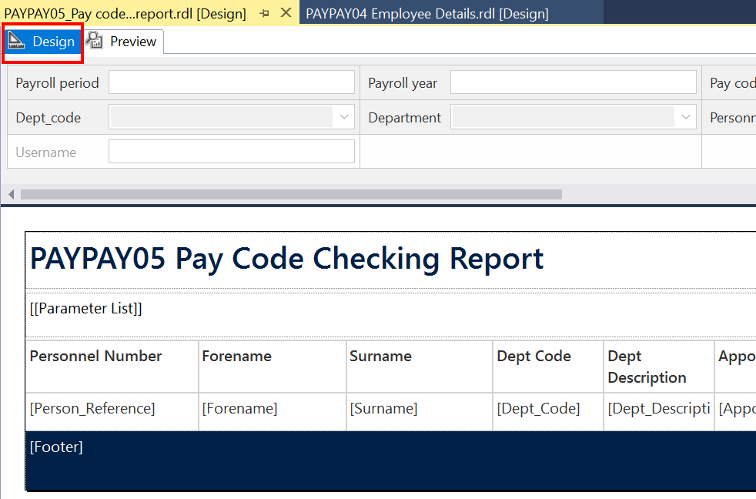

 | For more information about how to work with .RDL files, go to: HOW TO – Manage Reports – Report Files

Moving files in Visual Studio
You may at times need to move a file from one solution to another in Visual Studio (usually a report .RDL, but occasionally a shared dataset .RSD). This is in fact a key aspect of the release and deployment process, and detailed steps are provided in the Release and Deployment guide. A quick overview is given below.

To move a file from one solution to another, open the solution you want to add the file to – for example if you are moving an .RDL file from HR Reporting_DEV to HR Reporting_QA, you should open the QA solution.

Go to the Solution Explorer, then select the Reports folder and right-click it to open the sub-menu. Select Add > Existing Item… (or type Shift + Alt + A):

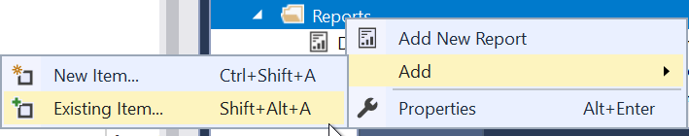

The solution folder on I:\OUIT\CoreHR Reports\ will open. This folder contains all the files which belong to your current HR Reporting solution:

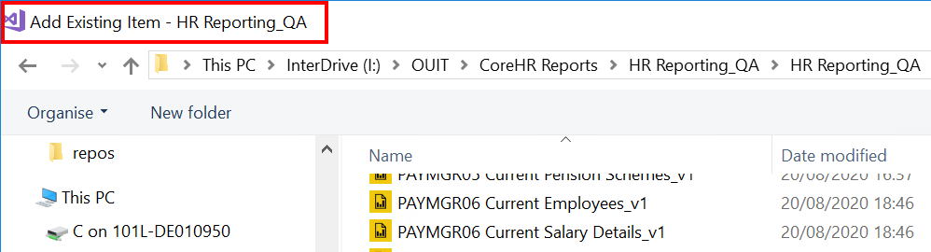

If you want to add an .RDL file from a different solution, navigate back to the main I:\OUIT\CoreHR Reports folder and select the solution folder you want to open.

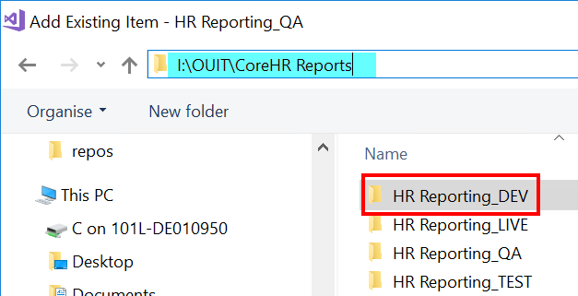

In this example, you can see from the title bar and the file path that you are selecting files from the DEV solution to add them to the QA solution:

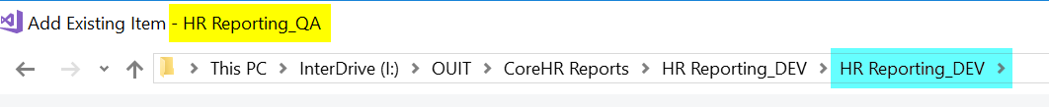

Scroll through the solution folder until you find the file you want to add to your current solution, then select it and click Add:

The .RDL file you have added will now appear at the bottom of the Reports list within the Solution Explorer of your current solution:

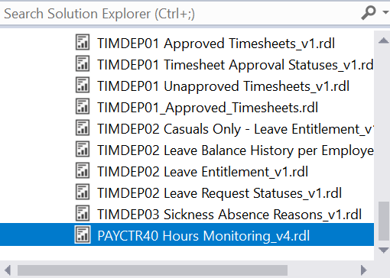

You can move multiple files to your current solution simultaneously – simply select all the files you wish to move before you click Add.

Deploying files from Visual Studio
Whenever you create a new shared dataset or report in Visual Studio, you will need to deploy it to the HR Reporting environments to make it available to report users. You must follow the how-to guide for full details of the release and deployment process, but a quick overview of how to deploy files is given here.

The deployment process is the same across all HR Reporting solutions and environments, and the steps are outlined below.

To deploy a file, select it in the Solution Explorer pane and right-click. Select “Deploy” from the right-click menu:

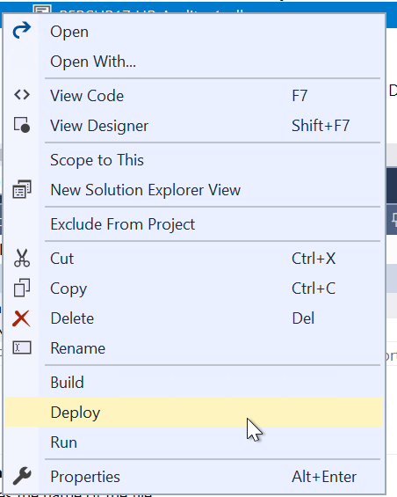

The progress of the deployment will display in the Output pane at the bottom of your screen. Look at the final message to see whether your deployment has succeeded or failed:

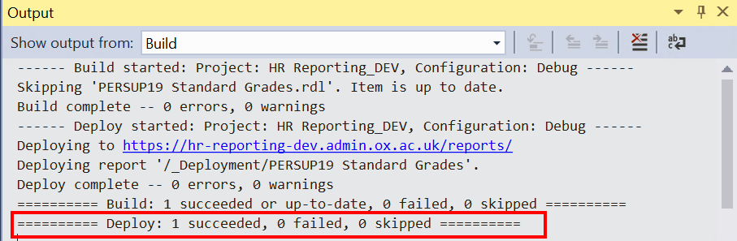

You can deploy multiple files simultaneously – simply select all the files you wish to deploy before you select “Deploy” from the right-click menu. Each file will be deployed individually by Visual Studio, and the results of your deployment will be displayed in the Output pane at the bottom of your screen:

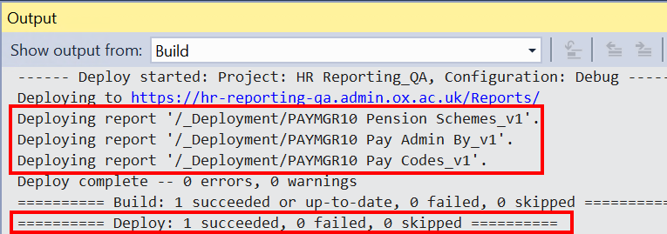

If your deployment has succeeded, the file will be available in the HR Reporting environment.
- If you have deployed a report (.RDL file), you can find it in the HR Reporting environment’s Home _Deployment folder.
- If you have deployed a shared dataset (.RSD file), you can find it in the HR Reporting environment’s Home Datasets (MASTER) folder.

